Chapter 1 results summary

**Macroeconomic predictors of forest cover change**

*Set 1 – macroeconomics*

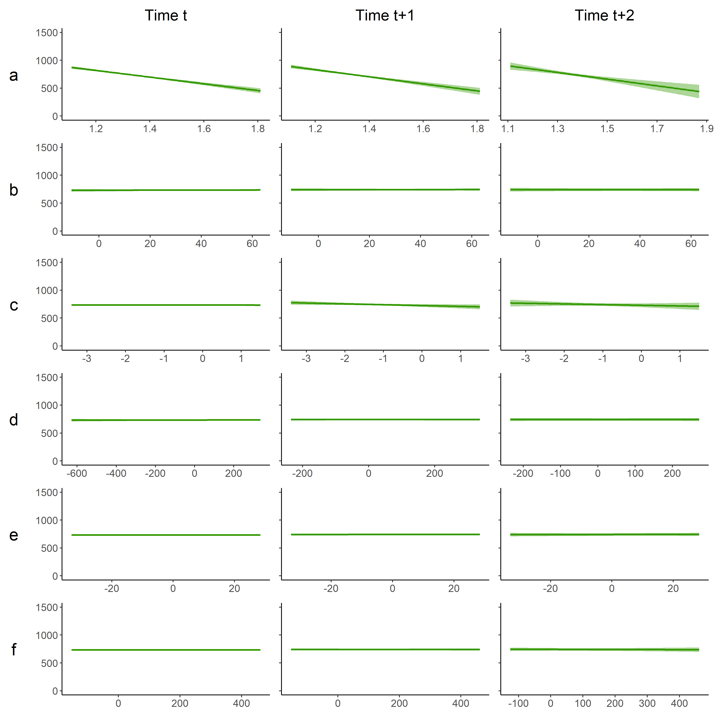

**Figure 1. Predicted relationship between forest loss and macroeconomic variables. All y-axes are the amount of forest lost in hectares. Row a: population density (individuals/km2), row b: Gross Domestic Product (GDP), row c: agricultural sectors contribution (%) to GDP, row d: development flows to the agricultural sector (USD millions), row e: development flows to the environment sector (USD millions), row f: Foreign Direct Investment (USD millions).The left column of plots are the effects on forest cover at time t (i.e. the variable values and forest loss values from the same year), the middle column of plots are the effects at time t+1 (i.e. the effects on forest loss in the subsequent year), and the right column of plots are the effects at time t+2 (i.e. the effects on forest loss two years after the variable values).**

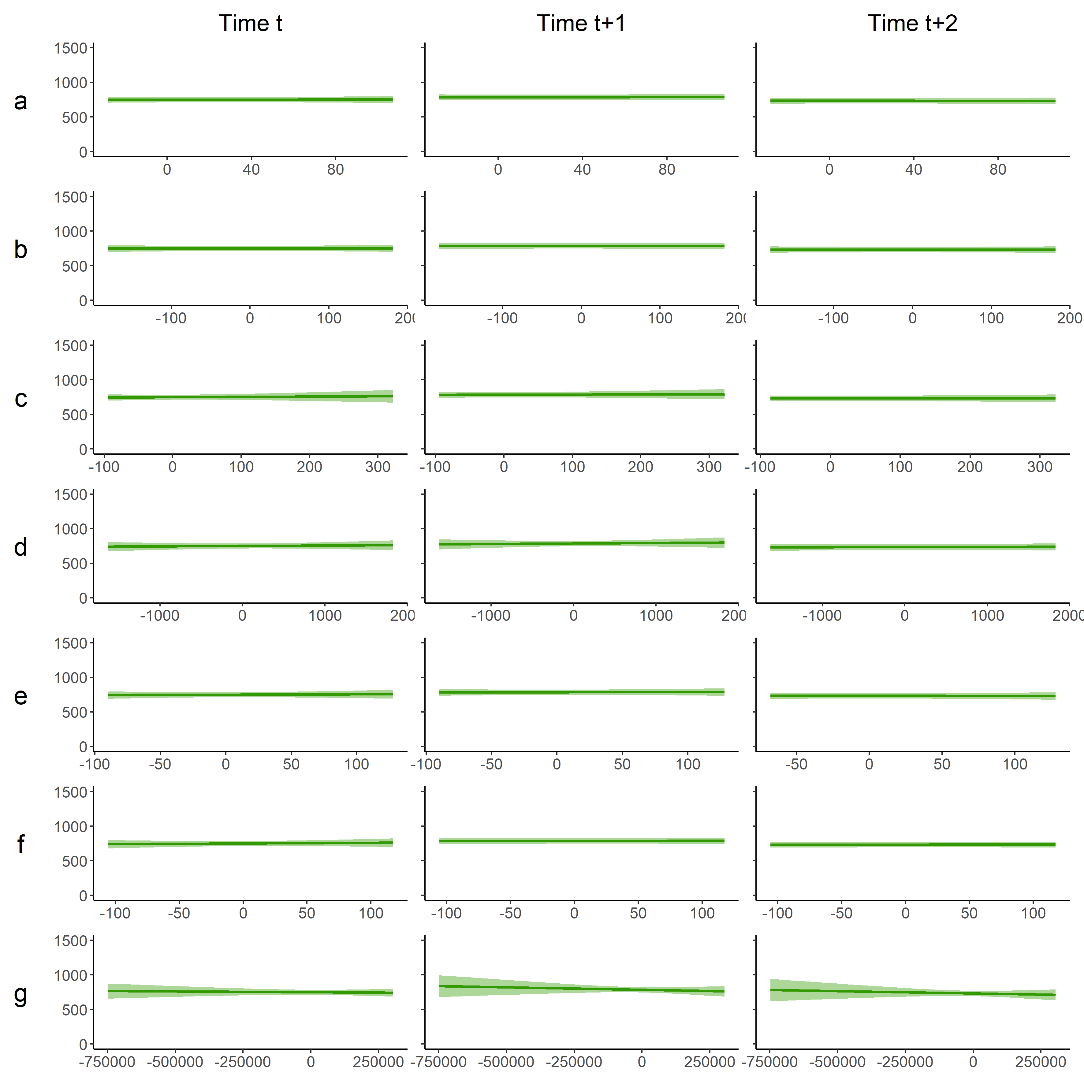

**Figure 2.** **Predicted relationship between forest loss and commodity variables. All y-axes are the amount of forest lost in hectares. Row a: Crop Production Index, row b: Non-food Production Index, row c: median annual market price for rice (USD/t), row d: median annual market price for rubber (USD/t), row e: median annual market price for corn (USD/t), row f: median annual market price for sugar (USD/t), row g: total production from forestry (m3). The left column of plots are the effects on forest cover at time t (i.e. the variable values and forest loss values from the same year), the middle column of plots are the effects at time t+1 (i.e. the effects on forest loss in the subsequent year), and the right column of plots are the effects at time t+2 (i.e. the effects on forest loss two years after the variable values).**

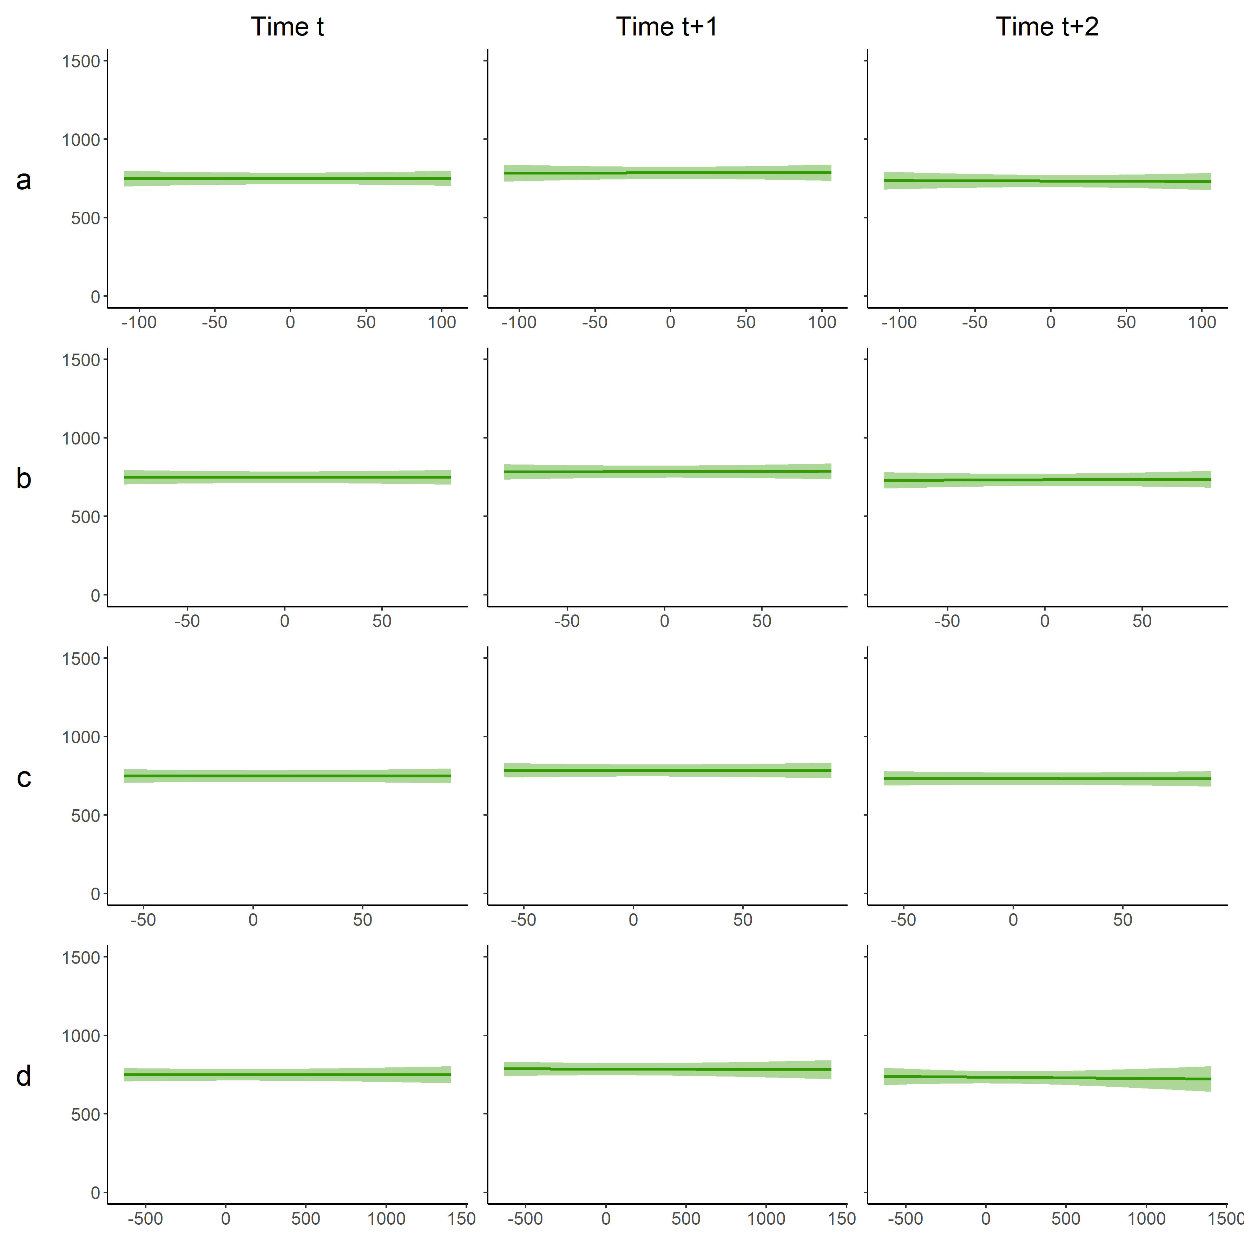

**Figure 3.** **Predicted relationship between forest loss and the producer prices (i.e. farmgate prices) variables. All y-axes are the amount of forest lost in hectares. Row a: producer price for rubber (USD/t) row b: producer price for cassava (USD/t), row c: producer price for corn (USD/t), row d: producer price for sugar (USD/t). Left column of plots are the effects on forest cover at time t (i.e. the variable values and forest loss values from the same year), the middle column of plots are the effects at time t+1 (i.e. the effects on forest loss in the subsequent year), and the right column of plots are the effects at time t+2 (i.e. the effects on forest loss two years after the variable values).**

**Socioeconomic predictors of forest cover**

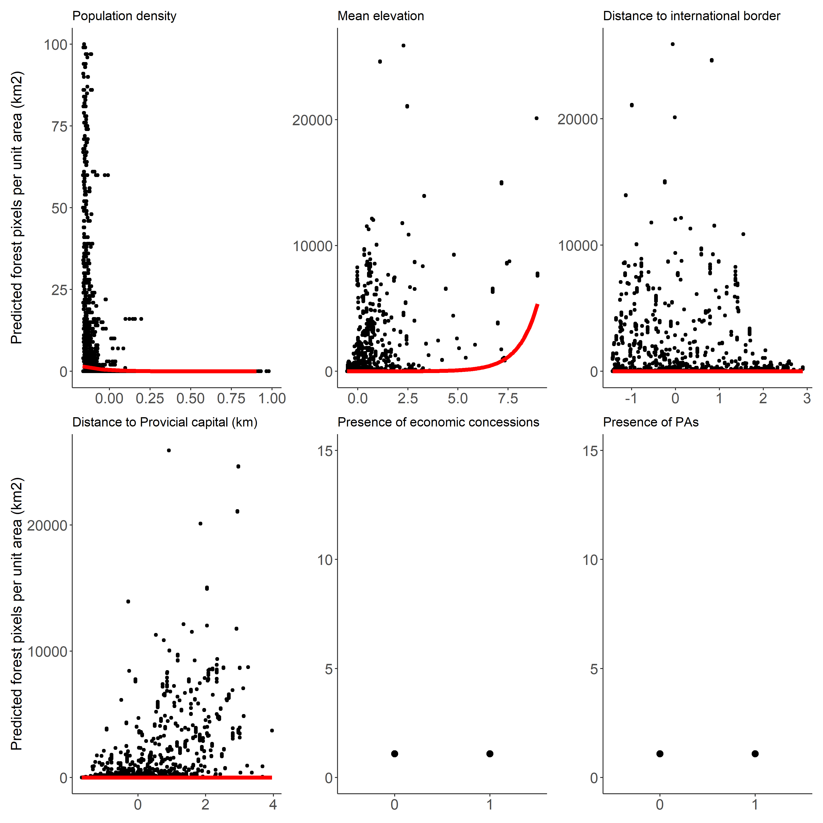

**Figure 4. Global predictions (i.e. predictions for an average commune within an average province) using the final model. X axes are the scaled predictors. Plots show the predicted values (red line) over the raw data.**